**DSP Lab Assignment**

Submitted By **Md. Fahim Shahriar (154440)**

**Built-In Conv Function**

**Code :**

x = [-1 2 1 3];

h = [-1 2 1];

n = length(x) + length(h) - 1;

X = 0:n-1;

Y = conv(x,h);

stem(X,Y);

xlim([-1 n]);

ylim([-6 8]);

**Result:**

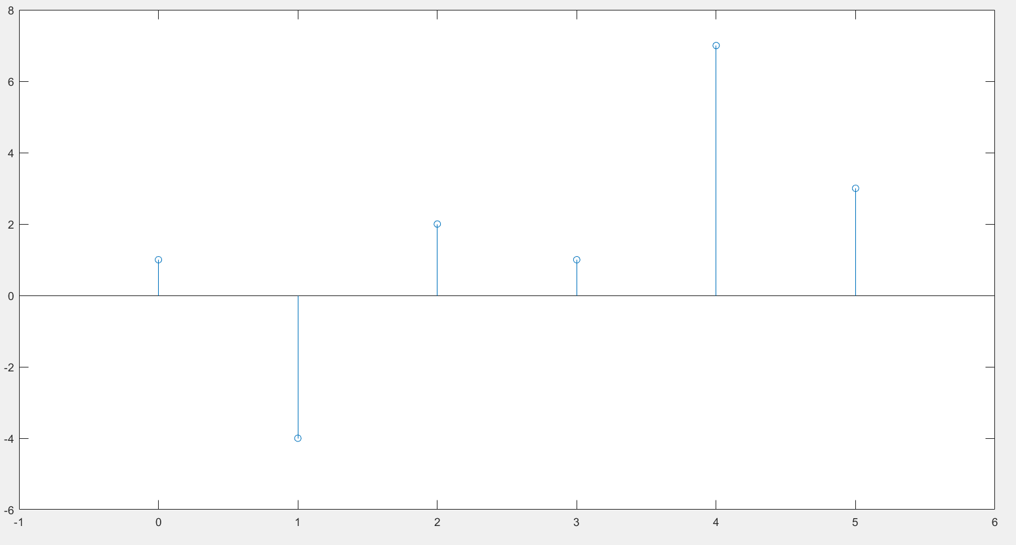

**Input Side Implementation of Convulation**

**Code :**

function [ C ] = input_conv(A , B)

n = length(A);

m = length(B);

C = zeros(1,n + m - 1);

for i = 1:n

k = 1;

for j = i:i+m-1

C(j) = C(j) + A(i) * B(k);

k = k + 1;

end

end

end

**Result :**

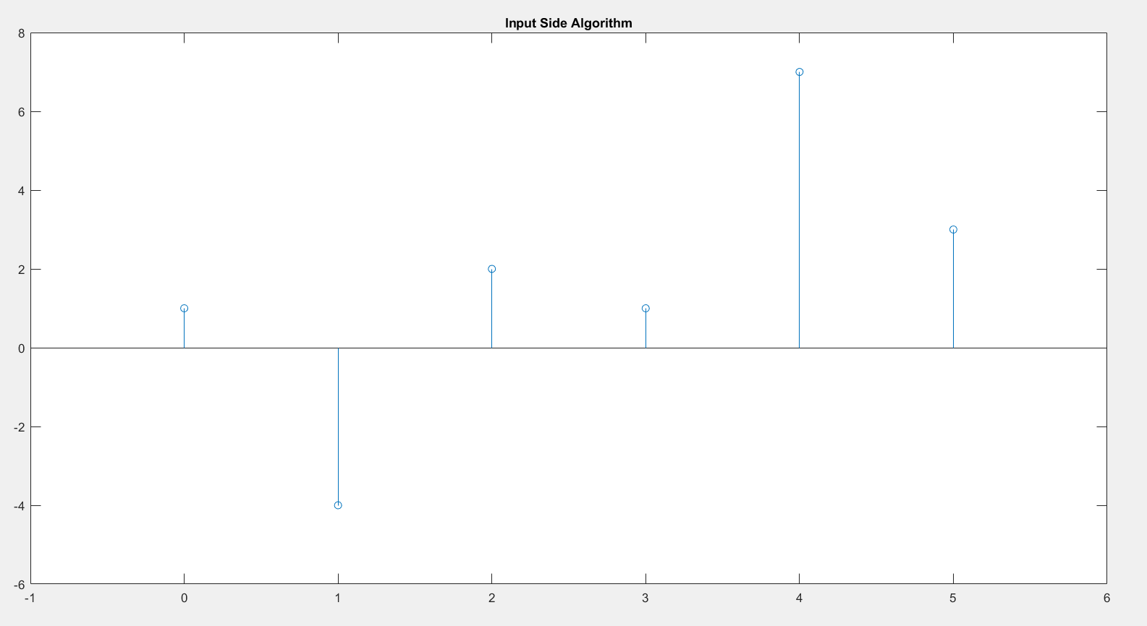

**Output Side Implementation of Convulation**

**Code :**

function [ C ] = output_conv( A , B )

n = length(A);

m = length(B);

C = zeros(1,n+m-1);

for i = 1:length(C)+1

for j = 1:m

if (i - j) > 0 && (i - j) <= n

C(i-1) = C(i-1) + B(j)*A(i-j);

end

end

end

end

**Result:**

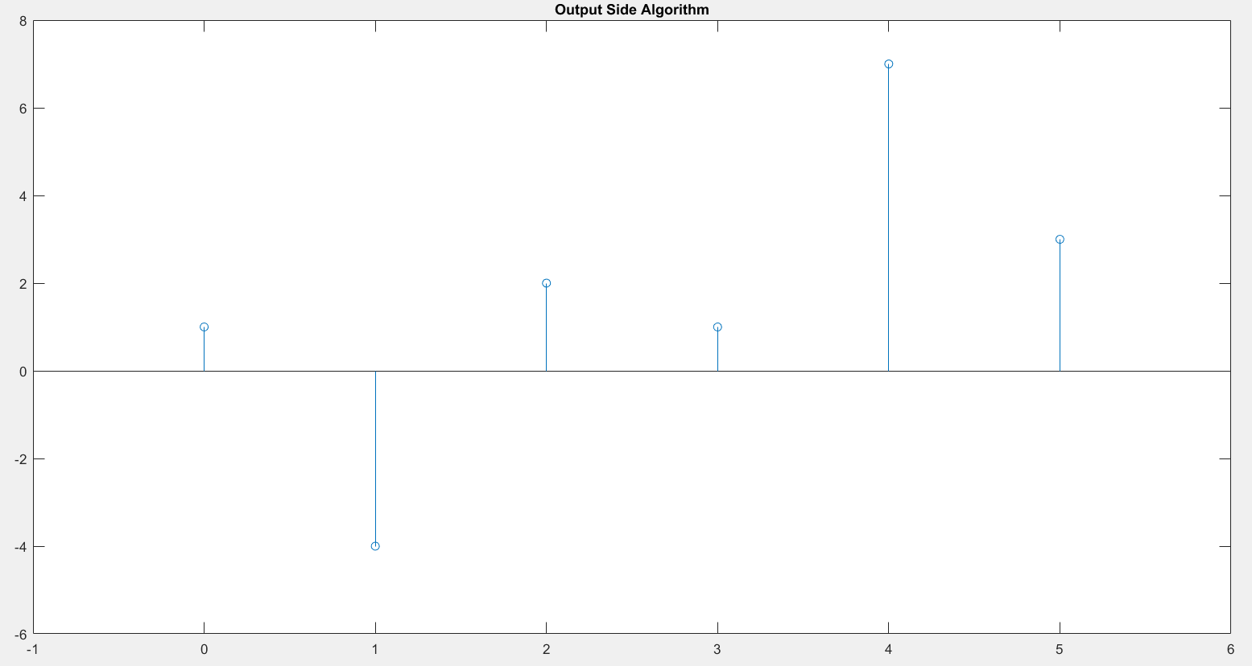

**Discussion :** Here the built-in convolution function and both of the algorithms gives us the same output. It also follows the formula for number of generated signals which is $n + m – 1$.